*Article*

Progress and Prospects of Research on Important Agricultural Heritage Systems: A Bibliometric Analysis Based on CiteSpace

Xinyong Lu**\***

College of Economy and Trade, Zhongkai University of Agriculture and Engineering, Guangzhou Guangdong, 510550, China.   
**\* Corresponding Author:** Xinyong Lu, luxinyong@zhku.edu.cn

Abstract

The Important Agricultural Heritage Systems (IAHS), a newly recognized category of cultural heritage, has garnered significant attention within the international scientific community. As global research on IAHS continues to grow, numerous scholars have conducted literature reviews on this subject. However, there remains a lack of visualized studies that effectively delineate emerging research trends. To address this gap, this study employs a bibliometric approach to provide a comprehensive analysis of the research progress and overarching development trends of the Global Important Agricultural Heritage Systems (GIAHS) from 2006 to 2023, offering valuable insights for the future development of related regions and nations. A total of 537 articles from the Web of Science Core Collection, published between 2006 and 2023, were analyzed using CiteSpace software. The findings reveal that international IAHS research can be divided into two phases: a fluctuating growth phase and a stable growth phase. Key countries and regions contributing numerous papers to core journals on IAHS include Canada, China, the United States, the Netherlands, the United Kingdom, and Italy. Influential institutions in IAHS research include the Chinese Academy of Sciences, University of Chinese Academy of Sciences, McMaster University, University of Twente, and the University of Toronto. Water Resources Research and Journal of Hydrology are the most frequently cited journals. Research hotspots over the past 18 years have concentrated on topics such as agricultural heritage systems, regeneration, agroforestry systems, dry stone walls, social capital, instability, and agricultural biodiversity. Research themes have primarily focused on GIAHS, tourism, livelihood assets, and georeferencing. Authors from different countries and regions have focused on distinct research themes. Based on the findings, future research should prioritize practical applications, micro–level perspectives, social science research, standardized quantitative methods, and expanding international collaboration. In–depth exploration in these areas will provide substantial support and guidance for the continued development of IAHS research.

Keywords: Important agricultural cultural heritage; CiteSpace; Globally important agricultural cultural heritage; Bibliometrics

# Introduction

In response to the global environmental challenges posed by traditional agriculture and the excessive use of chemical inputs, the Food and Agriculture Organization (FAO) of the United Nations launched the Globally Important Agricultural Heritage Systems (GIAHS) Conservation Project in 2002. GIAHS are defined as unique land use systems and agricultural landscapes that have evolved over time and dynamically adapted in rural areas and their surrounding environments. These systems are rich in biodiversity, meet local social, economic, and cultural needs, promote sustainable regional development, and are of significant value in enhancing rural ecological systems[1].

To be recognized as a GIAHS, traditional agricultural systems must fulfill five main criteria: food and livelihood security, biodiversity and ecosystem functions, knowledge systems and adaptation technologies, cultural value systems and social organization (agriculture), and compelling landscape and resource management practices endorsed by the FAO(Food and Agriculture Organization[2]. As of October 2023, 78 Important Agricultural Cultural Heritage (IACH) sites have been established globally, spread across 24 countries on five continents. Since 2012, National Important Agricultural Cultural Heritage Systems (NIAHS) have also been initiated. In Europe, for example, the Italian Ministry of Agriculture, Food, and Forestry Policies has established the National Register of Historic Rural Landscapes[3]. These IAHS systems, including both GIAHS and NIAHS, are dynamic, adaptive, composite, and sustainable[4].The promotion and implementation of GIAHS has generated substantial interest worldwide, emerging as a distinct field of research. Since the FAO's initial identification of GIAHS, literature related to IAHS has steadily increased, with 2006 marking the beginning of the field of IAHS research[5]. Therefore, a review of the research outcomes regarding internationally important agricultural cultural heritage over the past 18 years can provide deep insights into the evolving trends of both international and domestic agricultural cultural heritage.Research on globally important agricultural heritage systems began at different times in various countries, resulting in considerable variations in the depth, breadth, focus, and academic disciplines applied to IAHS research. To systematically summarize existing research findings and outline areas for future exploration, numerous scholars have conducted reviews. For instance, Kohsaka et al. utilized text mining to analyze official interviews, revealing practical issues related to citizen participation in GIAHS conservation[6]. Similarly, they examined official records of GIAHS certification issuance in Japan[7]. Kajima et al. employed text mining techniques to analyze official minutes from city council meetings, addressing issues surrounding GIAHS certification, especially the relationships between residents and visitors[8,9]. Nagata summarized the development of GIAHS in Japan over the past decade and proposed strategies for its sustainable development in the future[10]. Additionally, Zhang et al employed bibliometric methods to assess IAHS research papers published in China from 2005 to 2015, identifying research hotspots and future priorities in this field[11].

While many literature reviews on IAHS research focus on specific regions or countries, relatively few have adopted bibliometric methods to conduct an international review. More critically, as relevant research continues to emerge, scholars’ comprehensive understanding of the development of international GIAHS has become increasingly fragmented. With the expanding volume of studies, there is a pressing need to stay informed about the latest trends in global GIAHS–related research. A methodology that can clearly present these trends and guide future research directions is essential. CiteSpace, a powerful literature visualization tool, can address these challenges. Thus, this study utilizes the core literature from the Web of Science database as the sample base and visualizes and analyzes IAHS–related topics published between January 1, 2006, and November 8, 2023, using CiteSpace 6.2.R6 software. This paper not only summarizes the current state of IAHS research but also proposes future research directions, offering valuable insights for the development of the theoretical framework of IAHS.

# Data and methodology

* 1. **Data sources**

In this study, we conducted a literature search using the core journals from the Web of Science database, employing "agricultural cultural heritage," "GIAHS," "IAHS," and "important agricultural cultural heritage" as the key search terms. Since 2006, scholars have published papers addressing the background and concepts of GIAHS, marking the initial establishment of the IAHS research field[12]. As such, we restricted the literature search to articles published between January 1, 2006, and November 7, 2023. The types of literature included primarily consisted of English–language articles and reviews. After eliminating duplicate entries and papers that were unrelated to the topic, the search results provided a comprehensive overview of IAHS–related research over the past 18 years, summarizing the development trends within this field during that period.

* 1. **Methods of analysis**

CiteSpace, a widely recognized information visualization tool, not only uncovers the knowledge structure within a research field but also illustrates the knowledge evolution process of related areas through knowledge mapping [13]. Bibliometrics, grounded in quantitative research methods such as mathematical statistics, uses Bradford’s Law to determine the distribution of topics, thereby reflecting the research landscape and progression within a particular field[14]. Developed by Dr. Chaomei Chen at Drexel University, CiteSpace is a citation network visualization tool[15].

In this study, we utilized the latest version of CiteSpace 6.2.R6, integrating bibliometric methods to visualize and analyze IAHS research, ultimately constructing a knowledge map of the field. This approach facilitates a deeper exploration of the current status and emerging hotspots in GIAHS research. Through keyword co–occurrence and social network analysis, we identify key research hotspots [16]. Hotspot emergence analysis and co–occurrence clustering analysis effectively highlight prominent themes, where hotspots represent categories of keywords with shared characteristics. These hotspots offer valuable insights for analyzing the overarching trends in IAHS research. Consequently, in CiteSpace, hotspots are often used to predict future research trends[17].

Additional related terms in this paper stem from studies by Dr. Chaomei Chen and his colleagues. Readers are encouraged to consult relevant literature or books for further details. The knowledge map presented in this article represents the key research topics and hotspots within the international IAHS field.

# Analysis of research progress

## Analysis of IAHS Research Progress

1. **Changes in the number of publications issued**

To gain insights into the trends of Globally Important Agricultural Heritage Systems (GIAHS) research from 2006 to 2023, we analyzed the last 18 years of publications in the Web of Science core collection. The results of the literature search are illustrated in Figure. 1. The number of publications on GIAHS demonstrates clear fluctuations, followed by a general upward trend during this period (see Figure. 1). In 2006, only 16 articles were published, primarily offering brief introductions to GIAHS. By 2023, the number of published papers had increased to 38, reflecting growing academic interest.

**Figure 1:** Annual Distribution of International IAHS Research Publications from 2006 to 2023

Based on the fluctuating trends in the number of publications, we can categorize the development of international IAHS research into two distinct phases. The first phase, spanning from 2006 to 2014, is characterized as a fluctuating growth phase. During this period, the volume of literature remained relatively low, with a trend that initially increased and then declined, peaking at around 20 publications or fewer. Notably, two peaks in research activity occurred in 2008 and 2014. This indicates that IAHS research was still in its nascent stage during this period, with only a few institutions or researchers actively contributing to the GIAHS program and IAHS research.The second phase, from 2014 to 2023, marks a period of steady and sustained growth in the volume of literature, suggesting that international IAHS research is gaining momentum and increasing in prominence. The rising number of publications indicates that more international scholars are engaging with IAHS research from various perspectives. This phase signals the transition of IAHS research into a phase of rapid development and growing global recognition.

1. **Analysis of Publishing Countries and Institutions**

To gain a deeper understanding of the cooperation trends between different countries in the IAHS field and the influence of each country in this domain, we used the "Country" option in the node type column of CiteSpace 6.2.R6 software, setting the time range from 2006 to 2023. This enabled us to generate a country collaboration map, as shown in Figure. 2 and Table 1. Leveraging CiteSpace’s social network analysis functionality, we explored the social network relationships between countries and institutions involved in IAHS research at both macro and micro levels. This analytical approach provides a visual representation of the collaborative landscape of IAHS research, highlighting the cooperation patterns among different countries and institutions. Additionally, it reflects the influence of each country or institution in the international IAHS field[18]. Notably, the CiteSpace international collaboration map reveals the structural features of research clusters, emphasizing key nodes and significant connections within the network.

To gain a deeper understanding of international IAHS cooperation, we used CiteSpace software to generate a country node map, where each node represents a country, and the connecting lines indicate the level of collaboration between countries. The size of the nodes in the map reflects the number of IAHS–related publications produced by each country, while the thickness of the lines indicates the strength of collaboration between two countries[19]. By setting the "country" as the network node, we obtained a network map with 22 nodes and 225 connecting lines. This indicates that between 2006 and 2023, IAHS–related literature originated from 22 different countries. The density of the IAHS cooperation network was calculated as 0.3561 (see Figure. 2). This map highlights the extent of collaboration between these countries in the IAHS field. Among these countries, the top 10 with the highest number of IAHS publications are: Canada, China, the United States, the Netherlands, the United Kingdom, Italy, Australia, Sweden, France, and Austria (see Table 1). Observing Figure. 2 and Table 1, we find that the United Kingdom and Italy exhibit higher levels of collaboration with other countries, while China shows relatively lower levels of cooperation with other nations.

**Table 1.** High–Yield Countries in International IAHS Literature (2006–2023)

|  |  |  |  |  |
| --- | --- | --- | --- | --- |
| **sort** | **node number** | **centrality** | **country** | **percentage** |
| 1 | 189 | 0.47 | CANADA | 0.35 |
| 2 | 89 | 0.14 | CHINA | 0.16 |
| 3 | 83 | 0.11 | USA | 0.13 |
| 4 | 58 | 0.19 | NETHERLANDS | 0.09 |
| 5 | 49 | 0.09 | ENGLAND | 0.08 |
| 6 | 48 | 0.12 | ITALY | 0.08 |
| 7 | 32 | 0.3 | AUSTRALIA | 0.05 |
| 8 | 32 | 0.1 | SWEDEN | 0.05 |
| 9 | 28 | 0.14 | FRANCE | 0.04 |
| 10 | 26 | 0.04 | AUSTRIA | 0.04 |

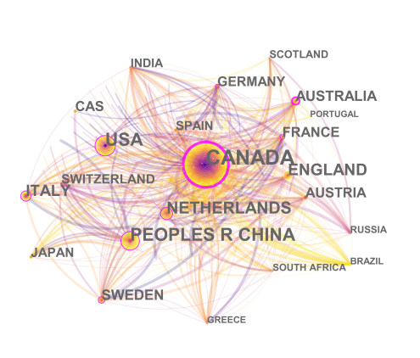

**Figure 2:** International Collaboration Map of IAHS Research from 2006 to 2023

Among the countries, Canada has published the most IAHS research papers (189), accounting for 35.20% of the total publications. Following Canada are China, the United States, the Netherlands, the United Kingdom, and Italy, which contribute 16.58%, 13.01%, 9.67%, 8.89%, and 8.56% of the total literature, respectively. Centrality reflects the importance of a node within the network (see Table 1). The centrality of a node represents the percentage of the shortest paths in the network that pass through that node[19]. The greater the node's degree of association, the higher its centrality, indicating its greater influence within the domain[15]. Canada has a centrality of 0.47, which indicates stronger collaboration with other countries in IAHS research. Although China ranks second in terms of the number of publications, its centrality is relatively low (centrality of 0.14). This suggests that China’s collaboration with other countries in international IAHS research remains weak.

A comprehensive understanding of high–level international research institutions involved in Global Important Agricultural Heritage Systems (GIAHS) helps to reveal the distribution of research institutions and the extent of international collaboration in the field. Therefore, this study focused on institutions and conducted a search for GIAHS–related literature in CiteSpace 6.2.R6. Using "organization" as the network node, a map was generated with 394 nodes, representing 394 core research institutions in the IAHS field. Chinese institutions include the Chinese Academy of Sciences, University of Chinese Academy of Sciences, Chinese Academy of Agricultural Sciences, Beijing Union University, Renmin University of China, and China Agricultural University. Representative institutions from other countries include McMaster University, University of Twente, University of Toronto, Delft University of Technology, University of Florence, Vienna University of Technology, Western University, University of Bologna, University of Padua in Italy, Commonwealth Scientific and Industrial Research Organisation (CSIRO) in Australia, and the University of Arizona in the United States (see Figure. 3 and Table 2).

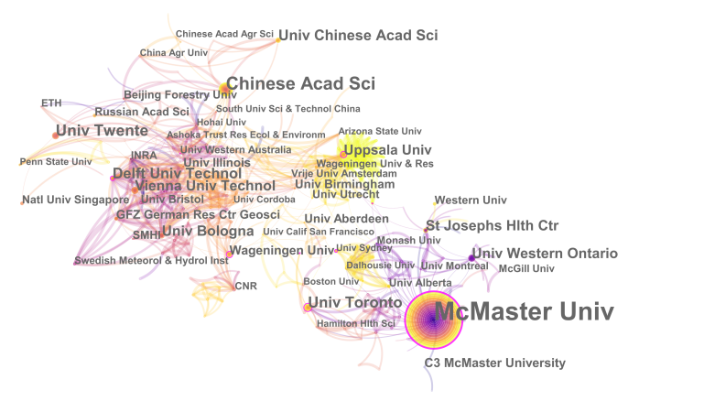

**Figure 3:** Academic Institutions in International IAHS Research from 2006 to 2023

**Table 2.** Institutions with More Than 16 IAHS Publications from 2006 to 2023

|  |  |  |  |
| --- | --- | --- | --- |
| **Rank** | **Number Nodes** | **Centrality** | **Institution** |
| 1 | 200 | 0.31 | McMaster Univ |
| 2 | 34 | 0.06 | Chinese Acad Sci |
| 3 | 21 | 0.03 | Univ Twente |
| 4 | 20 | 0.13 | Univ Toronto |
| 5 | 18 | 0.13 | Delft Univ Technol |
| 6 | 17 | 0.01 | Univ Chinese Acad Sci |
| 7 | 16 | 0 | Univ Florence |
| 8 | 16 | 0.04 | Vienna Univ Technol |
| 9 | 16 | 0.05 | Univ Western Ontario |
| 10 | 16 | 0.05 | Univ Bologna |

From 2006 to 2023, a total of 394 major research institutions were involved in IAHS research. Among them, 11 institutions published more than 16 papers, accounting for 2.79% of the total publications. The institution with the highest number of publications is McMaster University, contributing 37.24% of the total. It is followed by the Chinese Academy of Sciences, University of Twente, University of Toronto, and Delft University of Technology. McMaster University has the highest centrality in the IAHS research field, with a centrality value of 0.31, indicating its significant influence within the field. The Chinese Academy of Sciences and University of Twente have also published a substantial number of papers (Table 2).

1. **Analysis of Author Collaboration Groups**

By statistically analyzing the distribution of authors in the IAHS field, we can gain insights into their contributions and publication activity, offering a micro–level perspective on scholar engagement in the field. This analysis serves as a useful reference for evaluating scholars within the IAHS community and identifying key works for further reading. In this study, we utilized the "author" option in the node type column of CiteSpace 6.2.R6, setting the time frame from 2006 to 2023 and selecting the "Go Cluster" function. The resulting author collaboration map is shown in Figure. 4 and Table 3.

In the map, the size of the nodes represents the quantity of collaborations, with larger nodes indicating authors who have published more papers in the given year. The connections between nodes illustrate the collaborative relationships between different authors, with thicker lines signifying stronger collaborative ties. This visualization helps to reveal the central figures in IAHS research and their network of cooperation, offering valuable insights into the collaborative dynamics within the field.

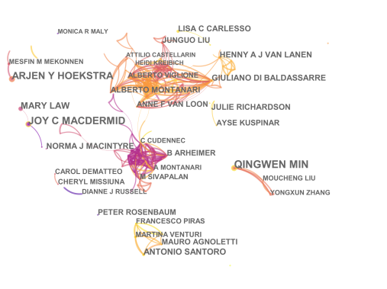

**Figure 4:** Collaboration Network of High–Productivity Authors in International IAHS Research from 2006 to 2023

**Table 3.** Scholars with More Than 9 Publications on IAHS Research from 2006 to 2023

|  |  |  |  |  |
| --- | --- | --- | --- | --- |
| **Rank** | **Number of Nodes** | **Centrality** | **Author** | **Percentage** |
| 1 | 22 | 0 | QINGWEN MIN | 0.17 |
| 2 | 19 | 0.04 | JOY C MACDERMID | 0.15 |
| 3 | 17 | 0 | ARJEN Y HOEKSTRA | 0.13 |
| 4 | 13 | 0.02 | MARY LAW | 0.10 |
| 5 | 11 | 0 | ANTONIO SANTORO | 0.08 |
| 6 | 10 | 0.02 | HENNY A J VAN LANEN | 0.08 |
| 7 | 10 | 0.03 | GIULIANODIBALDASSARRE | 0.08 |
| 8 | 10 | 0.01 | NORMA J MACINTYRE | 0.08 |
| 9 | 9 | 0 | LISA C CARLESSO | 0.07 |
| 10 | 9 | 0 | JULIE RICHARDSON | 0.07 |

The purple outline around the nodes indicates that the authors possess strong centrality, serving as key figures within the research network. Based on the analysis, several collaboration groups were identified:

Group 1: ALBERTO MONTANARI, ALBERTO VIGLIONE, ANNE F VAN LOON, ATTILIO CASTELLARIN, HEIDI KREIBICH, among others[7];

Group 2: NORMA J MACINTYRE, B ARHEIMER, C CUDENNEC, A MONTANARI, M SIVAPALAN, etc. [20];

Group 3: PETER ROSENBAUM, FRANCESCO PIRAS, ANTONIO SANTORO, MAURO AGNOLETTI, MARTINA VENTURI[9];

Group 4: QINGWEN MIN, MOUCHENG LIU, YONGXUN ZHANG, etc[21]. (see Figure. 4).

The prominent purple outline around the node of ALBERTO MONTANARI highlights his strong centrality in the network, indicating his role as a regional bridge between different author communities or institutions. His ability to control and distribute information has made him a leader in IAHS research. A red circle in the collaboration network centered on ALBERTO MONTANARI appeared between 2015 and 2017. During this period, researchers from Canada, such as Wall, G., and U.S. researchers like Fulle, established a level of cooperation with Chinese authors. Additionally, Italian researchers like Santoro, A. formed close collaboration networks with authors from Tunisia and El Salvador[22,23], suggesting Italy's strong representation in IAHS research.

As international collaboration in GIAHS research gradually strengthened, further analysis revealed that Japanese authors such as Kohsaka, R., Uchiyama, Y., and Kajihara, H. have also developed regional connections with Korean authors like You, W.H. and Chinese authors. These core authors play a crucial role in leading and advancing the field of IAHS. Based on the methodology for determining core authors, which is based on the number of publications, it was found that QINGWEN MIN is the author with the highest number of papers, publishing 22 articles. Thus, Nmax = 22, and N1 ≈ 9. Authors who have published more than nine papers are considered core contributors to the IAHS field[18]. According to the statistics, there are 11 core authors in IAHS research, with a total of 139 papers, representing 25.88% of the total literature in international IAHS research. However, the formation of a core author group requires that the core authors contribute 50% of the total publications in the field, which this threshold does not meet. Therefore, a core group of authors has yet to be fully established in IAHS research.

1. **Cited Authors and Journals**

To systematically understand the authors and their publication impact, we selected the "Cited Authors" and "Cited Journals" options in the node type column of CiteSpace 6.2.R6, with the time frame set from 2006 to 2023. After running the software, we obtained citation networks for authors and journals, as shown in Table 4 and Table 5. These networks reveal the academic community within the research field. By analyzing the co–citation of journals, we can identify the knowledge base of a specific research area[15].

The most cited author, ANONYMOUS, has been cited 285 times. Among the journals, Water Resources Research and Journal of Hydrology are the most frequently cited, each with 124 citations. Both journals have an impact factor of 5.4 (Q1) and 6.4 (Q1), respectively, in 2023. Table 4 and Table 5 provide rankings of influential authors and journals in the field of IAHS.

**Table 4.** Top 8 Most Cited Authors in IAHS Research

|  |  |  |
| --- | --- | --- |
| **Cited Times** | **Centrality** | **Cited Author Name** |
| 285 | 0.44 | ANONYMOUS |
| 38 | 0.07 | MONTANARI A |
| 38 | 0.25 | FAO |
| 37 | 0.05 | DI BG |
| 34 | 0.04 | SIVAPALAN M |
| 34 | 0.09 | BL枚SCHL G |
| 29 | 0.07 | KOOHAFKAN P |
| 28 | 0.03 | HOEKSTRA AY |
| 24 | 0.07 | AGNOLETTI M |
| 23 | 0.03 | BLOSCHL G |

**Table 5.** Top 10 Most Cited Journals in IAHS Research

|  |  |  |  |
| --- | --- | --- | --- |
| **Cited Times** | **Centrality** | **Year** | **Cited Institution** |
| 124 | 0.02 | 2006 | WATER RESOUR RES |
| 124 | 0.01 | 2006 | J HYDROL |
| 123 | 0.01 | 2008 | HYDROL EARTH SYST SC |
| 112 | 0.14 | 2011 | P NATL ACAD SCI USA |
| 106 | 0.10 | 2006 | NATURE |
| 103 | 0.01 | 2006 | HYDROL PROCESS |
| 95 | 0.31 | 2007 | SCIENCE |
| 92 | 0.01 | 2008 | HYDROLOG SCI J |
| 69 | 0.08 | 2006 | ARCH PHYS MED REHAB |
| 65 | 0.04 | 2008 | GEOPHYS RES LETT |

## Cluster Analysis of Research Hotspots

Keywords serve as key indicators of the research hotspots and trends within a specific field. By ranking keywords based on their frequency, scholars can gain a deeper understanding of the central topics and the most influential terms within the field. In this study, we used CiteSpace 6.2.R6 to analyze the extracted literature, selecting the "keywords" option in the node type column, with the time frame set from 2006 to 2023. The resulting country collaboration map is shown in Table 6.

**Table 6.** Centrality and Frequency Statistics of High–Frequency Keywords in International IAHS Research from 2006 to 2023

|  |  |  |  |
| --- | --- | --- | --- |
| **No.** | **Frequency** | **Centrality** | **Keyword** |
| 1 | 43 | 0.46 | impact |
| 2 | 41 | 0.13 | climate change |
| 4 | 36 | 0.26 | management |
| 4 | 29 | 0.03 | GIAHS |
| 5 | 23 | 0.24 | model |
| 6 | 22 | 0.32 | System |
| 7 | 20 | 0.06 | landscape |
| 8 | 16 | 0.07 | Sustainability |
| 9 | 16 | 0.19 | reliability |
| 10 | 16 | 0.12 | rehabilitation |
| 11 | 16 | 0.09 | conservation |
| 12 | 13 | 0.04 | agricultural heritage |
| 13 | 13 | 0.22 | China |
| 14 | 12 | 0 | agricultural heritage system |
| 15 | 12 | 0.01 | biodiversity |
| 16 | 10 | 0.02 | prediction |
| 17 | 10 | 0.2 | tourism |
| 18 | 9 | 0.04 | uncertainty |
| 19 | 8 | 0.01 | land use |
| 20 | 8 | 0.07 | performance |

By ranking 158 keywords from 2006 to 2023 based on their frequency, we determined the number of papers that included each keyword. The most frequently used keywords include impact, climate change, management, Global Important Agricultural Heritage Systems (GIAHS), models, systems, landscapes, sustainability, reliability, restoration, environmental protection, agricultural heritage, China, agricultural heritage systems, biodiversity, prediction, tourism, uncertainty, land use, and performance (see Table 6). Keywords related to the impact of agricultural heritage and ecosystem services show a high centrality, with centrality values above 0.3, indicating that multiple papers have cited these terms. In the GIAHS field(Food and Agriculture Organization)[21], scholars have focused on topics such as heritage management, heritage landscapes, land use, water resources, and terraced landscapes[24]. Researchers have also delved into significant landscape features related to agricultural heritage, land and water resource management, as well as biodiversity, ecosystem services, heritage diversity, climate change impacts, and sustainability in agricultural heritage. These research themes align closely with the unique characteristics of GIAHS in terms of biodiversity and ecosystem functionality.Beyond the examination of agricultural heritage issues, scholars have also explored topics related to food and livelihood security. These studies are integral to the sustainable livelihoods framework and provide theoretical support for sustainable agricultural practices. Past research has predominantly concentrated on heritage tourism, heritage systems, agricultural heritage systems, and China's agricultural heritage. These topics align with cultural values, value systems, and social organization in agriculture, offering valuable perspectives on the maintenance and transmission of agricultural heritage.

Lastly, scholars have dedicated considerable efforts to heritage conservation and traditional knowledge systems, with these studies emerging as key areas of research. These themes resonate with the characteristics of knowledge systems and adaptive technologies, playing a crucial role in the protection and preservation of agricultural heritage.

Using CiteSpace, we conducted a visualized cluster analysis of IAHS keywords, which helped identify the key research hotspots in the international IAHS field. The timeline view, shown in Figure. 5, emphasizes the relationships between clusters and the historical evolution of key topics. By applying

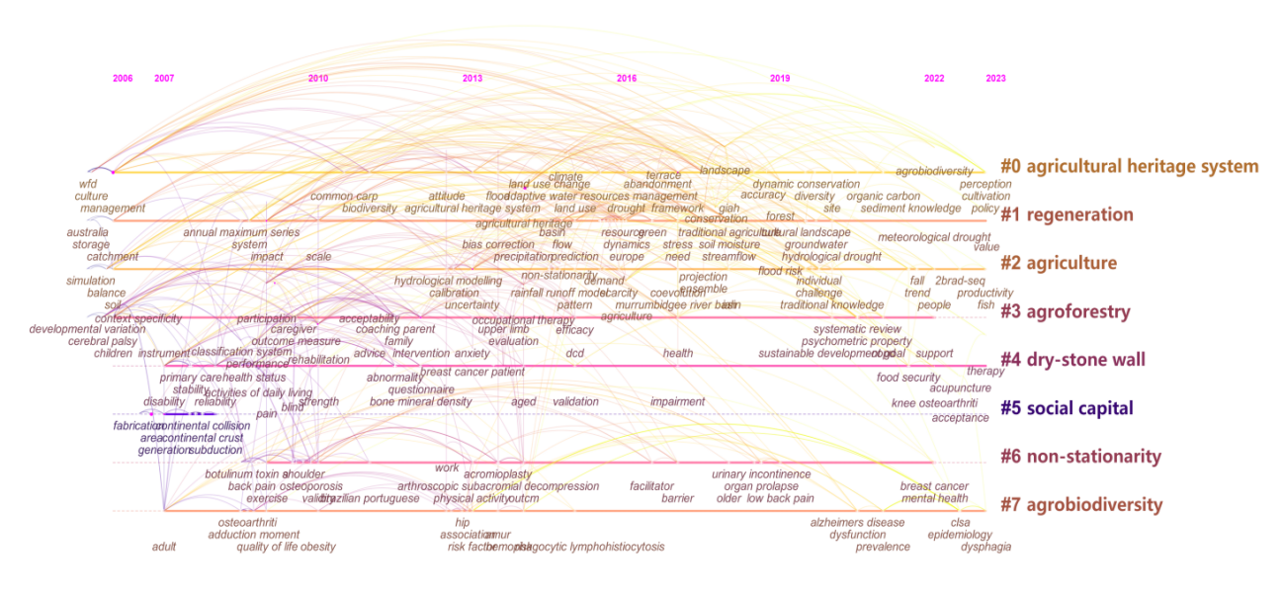CiteSpace’s timeline function, we distributed keywords according to their emergence over time. After the formation of clusters, we selected the timeline view option in the control panel. In the resulting visual, the size of each ring on the timeline reflects the frequency with which the corresponding keyword or research theme has been cited. The larger the ring, the higher the citation frequency, indicating the increasing significance of that keyword or theme within the international IAHS research field. This visualization enables us to more clearly identify the evolving trends and key hotspots in IAHS research.

**Figure 5:** Co–occurrence Timeline of International IAHS Keywords from 2006 to 2023

As time progresses, the timeline chart, shown in Figure. 5, is created based on high–centrality keywords within the clusters. The key research hotspots along the timeline focus on the following keywords:

#0 Agricultural Heritage Systems #1 Regeneration

#2 Agriculture #3 Agroforestry Systems

#4 Dry Stone Walls #5 Social Capital

#6 non–stationarity #7 Agrobiodiversity

In the timeline of #0 Agricultural Heritage Systems, the first clustering keyword, "land use," appeared in 2008[25]. Over time, related keywords gradually increased, including "culture," "China," "landscape use," "landscape," and "terraces." From 2006 to 2019, keywords primarily focused on "landscape use," "China," and "terraces." By 2020, new keywords such as "terrace landscapes," "nitrogen balance," and "site selection" emerged. This suggests that early international research on IAHS primarily concentrated on the development of system landscapes[26,27], with initial focus on landscape use methods[28,29]. Subsequently, research shifted to focus on regional landscapes, particularly in countries like China[30], and later on specific forms such as terrace landscapes [31,32]. In recent years, the research direction has expanded to ecological element balance, such as nitrogen balance, with a primary focus on site selection issues in IAHS[33].

In the timeline for #1 Regeneration, the first keyword, "biodiversity," appeared in 2011[28], followed by terms like "ethnobotany," "food security," and "cultural landscapes." From 2018 to 2023, the keywords expanded to include "traditional agriculture," "soil," "value," and "agroecosystems." Early research on IAHS regeneration focused on promoting regeneration through biodiversity conservation[9,34]. The focus gradually shifted towards more abstract aspects of regeneration, including food security, heritage, knowledge, and cultural landscapes[29]. The research also began to explore the regeneration of agricultural production factors, such as the revival of traditional knowledge and soil regeneration at IAHS sites. The scope of research expanded further to include ecosystem regeneration[34].

On the #2 Agriculture timeline, the first keyword, "sustainability," appeared in 2012[35]. In 2015, keywords like "climate change," "watersheds," "resilience," and "agriculture" emerged, followed by "Spanish national research" in 2017, and by 2020, the latest terms were "adaptation," "strategies," and "quality." This trend suggests that early research in international IAHS focused on rural development and environmental protection issues[36]. The perspective of research expanded from a global view on climate change to a regional focus on changes within specific areas[37], and further down to the micro–level of agricultural production systems, focusing on agricultural quality improvement and solutions[38]. The primary research themes examined the impacts of IAHS on global agricultural adaptation, resilience, and sustainability[39].

In the timeline for #3 Agroforestry Systems[40,41], the first keyword, "system," appeared in 2006[31]. From 2012 to 2017, keywords like "management," "Europe," "region," and "food" emerged. In 2023, new keywords included "traditional knowledge," "mid–mountain," and "services." Early IAHS research focused on the wealth and management of IAHS itself. Over time, the research extended to the factors related to IAHS development. Initially, the focus was on the primary industry, gradually expanding to the secondary and tertiary sectors. The scope evolved from global system management to regional system management, and later to specific site–based management[34,36]. The content progressed from general system functionality and management to more specific studies on tourism and traditional knowledge within case study regions[37,42].

In the #4 Dry Stone Walls timeline, the first term "ecosystem services" appeared in 2014[43]. Between 2015 and 2019, keywords like "prediction[44]," "runoff," "cultural heritage," "abandonment," and "perception" emerged. By 2022, new terms like "agricultural systems" and "life cycle assessment" appeared. Research on "dry stone walls" has primarily focused on ecosystem service functions, runoff, landscapes[35], cultural heritage, and the abandonment of dry stone walls[40]Studies on dry stone walls in IAHS have evolved from focusing on the characteristics of dry stone wall systems to their changes and existing issues, and more recently, to analyzing their entire lifecycle[32].

On the #5 Social Capital timeline, the first terms "storage" and "water" appeared in 2007[45]. Between 2014 and 2015, keywords like "stakeholders," "West Africa," and "Bangladesh" emerged. In 2018, "GIAHS" appeared, and by 2020, "denitrification" was introduced. Research on social capital has expanded from a micro–level perspective on resources to regional and human impacts, focusing on the development of climate factors and the growth of GIAHS[46]. Human factors often relate to the natural conditions of heritage sites and the distribution of benefits among heritage site residents and stakeholders. Research has since broadened to include strategies to improve and optimize livelihoods from the perspective of capital and income[47]. Throughout this research, natural resources, such as water, play a key role, as water resources are critical to tourists and support the sustainable development of IAHS[48].

On the #6 Instability timeline, the first term appeared in 2014[39], with "denitrification" emerging in 2020. Research on instability in IAHS primarily focuses on the instability caused by climate change[49]. The focus has shifted from large–scale geographic models to specific geographic models within particular domains[50].

Lastly, on the #7 Agricultural Biodiversity timeline, the first term "dynamics" appeared in 2011[45], followed by "agricultural biodiversity" in 2013, "farmers" in 2016, and "seed exchange networks" in 2019. Research on agricultural biodiversity in IAHS covers a wide range, from the overall study of agricultural biodiversity to its maintenance and the protection of agricultural biodiversity through germplasm exchange[51,51,53].

## Analysis of Keyword Emergence in International IAHS Research

Emergent keywords refer to terms that appear frequently over a short period, reflecting the research hotspots that scholars focus on during a specific time. These keywords are crucial for understanding the evolution and development trends of a field during a given period. CiteSpace software enables the detection of emergent keywords based on the frequency changes of terms over time. By analyzing the frequency fluctuations of emergent keywords[15], we can uncover shifts in the research hotspots and trends within the field. These instantaneous changes reflect specific issues that scholars focused on during particular periods[54].In CiteSpace 6.2.R6, we set the topn=20 parameter. "Keyword" represents the type of node (i.e., the keyword), "Year" indicates the year the keyword appeared, "Intensity" shows the frequency of its occurrence, "Begin" marks when the keyword started appearing, and "Close" marks when it stopped appearing.

By using these settings, we were able to accurately track the evolution of keywords over time and identify the emergence of research hotspots. This approach helps provide a comprehensive understanding of the development trends in IAHS research. In this study, we will detail the results from CiteSpace, focusing on the evolution paths of emergent keywords to gain deeper insights into the dynamic research trends in the IAHS field.

Finally, Figure. 6 shows the top 21 emergent keywords in international IAHS research from 2006 to 2023. The highlighted red line in the image indicates the duration of each keyword’s prominence. Based on the phase–by–phase changes in keywords, we can divide the evolution of IAHS research into four stages:

**Phase 1 (2006–2013):** During this stage, international IAHS research primarily focused on management, biodiversity, and diversity, discussing IAHS characteristics and usage from a macro perspective[22,53].

**Phase 2 (2014–2016):** The research hotspots shifted towards heritage, environment, uncertainty, areas, and forests. This phase emphasized research on natural environments and regional issues[7,31,55].

**Phase 3 (2017–2019):** Research topics concentrated on impact, climate change, diversification, sustainability, region, and perception. During this phase, scholars began focusing on the regional aspects of the research and the perceptions of farmers in those areas[56].

**Phase 4 (2020–2023):** The focus shifted to cultural heritage, frameworks, models, sustainability, and GIAHS. Increasingly, scholars recognized the issues surrounding the protection and development models of international IAHS and began addressing the inheritance, development, and value of IAHS systems[57,58].

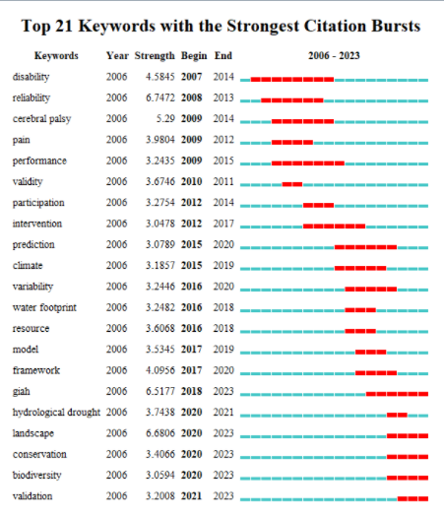

**Figure 6:** The Top 21 Most Prominent Keywords in International IAHS Research from 2006 to 2023

## Cluster Analysis of Topic Co–occurrence

The cited literature within a research dataset reflects the knowledge base of a field. Topic clustering of cited literature reveals the frontier knowledge and important turning points in the evolution of that knowledge. It also clarifies the relationships between different research frontiers[15]. To better understand the development trends and the current state of the frontier topics within GIAHS research, this study set a one–year time frame and applied a logarithmic likelihood ratio algorithm to generate the clustering map of topic terms, as shown in Figure. 7.

The clustering map highlights keywords from 2006 to 2023, with the red font representing the major research topics of that period. The map is followed by a co–occurrence timeline of topic terms and a clustering of IAHS keywords from 2006 to 2023. Each axis represents authors and their publication times, corresponding to the topics on the right axis and the first citation time of the related documents.

Based on the topic term clusters and the co–occurrence timeline analysis, we identified four well–defined clusters (see Figure. 7, numbered 0, 2, 3, and 9). The smaller the number, the more keywords are included in the cluster. Each cluster contains multiple closely related terms. Other cluster results, which have been summarized previously, are excluded. The colors on the timeline correspond to the citation documents associated with each node, representing different years. The same color links authors collaborating on the same topic across different years[23,59].

These clusters reflect the research hotspots in international IAHS from 2006 to 2023, including:

0# Global Important Agricultural Heritage Systems

2# Tourism

3# Livelihood Assets

9# Direct Georeferencing

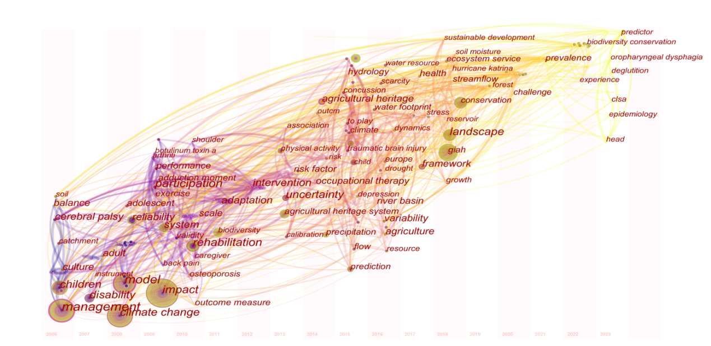

**Figure. 7:** Co–occurrence Timeline of International IAHS Topics from 2006 to 2023

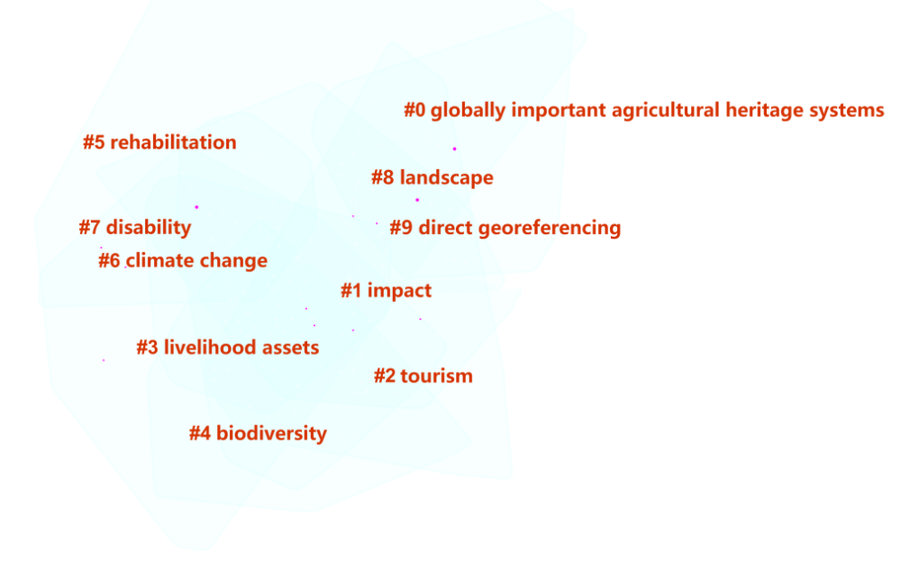

**Figure. 8:** Clustering of International IAHS Topic Keywords from 2006 to 2023

0# Global Important Agricultural Heritage Systems (GIAHS): According to the citation frequency analysis of core literature, key studies focus on the transmission mechanisms of traditional knowledge at heritage sites, the dynamic adaptation of heritage and protection strategies, and the tourism development and utilization of heritage resources[48,52].

2# Tourism: In core literature, scholars primarily explore the relationship between tourism and farmers' livelihood capital[60,61], as well as the sustainable development of tourism resources. In terms of livelihood capital, research mainly focuses on ecological compensation and government policies supporting livelihood sustainability. Regarding tourism resources and sustainability, scholars examine the impact of tourism on farmers' sustainable income and livelihood sources, along with the identification, development, and protection of tourism resources.

3# Livelihood Assets: Core journal articles focus on the capital investments of community residents, including the measurement of farmers' livelihood capital, land use, sustainable livelihoods, and labor migration. The research methods employed include case studies, coupling measurements, and others[62,63].

9# Direct Georeferencing: Core journal literature concentrates on various perspectives, including remote sensing technology measurement, topographic map time and spatial measurement, hydrological models, and rainfall–runoff models. Key papers primarily focus on the direct application of geographic measurement tools and methods in the IAHS field, as well as the mechanisms by which these tools and methods contribute to the development of IAHS[5,17].

Overall, from the perspective of co–occurrence clustering analysis, current global research on Important Agricultural Heritage Systems mainly centers on integrated studies of protection and sustainable development. Additionally, scholars are focusing on other areas such as tourism, livelihood assets, and geographic information analysis of international agricultural heritage.

# Conclusion and Outlook

This study utilizes the bibliometric visualization software CiteSpace 6.2.R6 to analyze 537 IAHS research papers from the Web of Science core dataset, creating a visual network analysis that includes distributions of authors, institutions, countries, keywords, and subject terms. Our analysis, based on the visual distribution of authors, institutions, and countries, provides an overview of international IAHS research from 2006 to 2023. Building upon this, we explored the topic and keyword distributions, and conducted an in–depth analysis of the research trends and hotspots in international IAHS research. The main conclusions are as follows:

## Results

### Known Results

**(1) Research Phases and Publication Trends:** The international IAHS research from 2006 to 2023 can be divided into two distinct phases: the fluctuating growth phase (2006–2014) and the stable growth phase (2014–2023). While the overall trend shows an increase in publications, the number of IAHS papers remains relatively low compared to other academic fields.

**(2) Institutional Network in GIAHS:** The major institutions involved in IAHS research include McMaster University, University of Twente, the Chinese Academy of Sciences, University of Chinese Academy of Sciences, and the University of Toronto. Regarding publication by country, Canada, China, the United States, the Netherlands, the United Kingdom, Italy, and Australia lead in the number of published papers. Despite China’s high volume of publications, its centrality is relatively low, indicating the need for China to strengthen international scientific collaboration to enhance its global influence in GIAHS research.

**(3) Author Collaboration and Research Networks:** IAHS research involves multiple author groups, with key contributors from countries such as Canada, China, Italy, Japan, the United States, the Netherlands, and the United Kingdom. However, a global core author group has yet to form, suggesting significant potential for broader international collaboration in the field.

**(4) Highly Cited Authors and Journals:** In the Web of Science core collection, the most frequently cited author in the IAHS field is ANONYMOUS, whose works have been cited 285 times. The most cited journals are Water Resources Research and Journal of Hydrology, each with 124 citations, with impact factors of 5.4 (Q1) and 6.4 (Q1) in 2023. In terms of keywords, the most prominent terms in international IAHS research include agricultural heritage systems, regeneration, agriculture, agroforestry systems, dry stone walls, social capital, instability, and agricultural biodiversity. From 2006 to 2023, the research focused mainly on GIAHS, tourism, livelihood assets, and direct georeferencing. Overall, the research papers are highly concentrated in areas such as geography, tourism, capital donations, and biodiversity.

### Unexpected Results

Through the analysis of cited literature, several unexpected spatial connections and differences have emerged:

**(1) Geographical Distribution of Research:** The geographical distribution of GIAHS research authors is predominantly concentrated in Asia, including countries such as China, Japan, and India. In Europe, key countries include Italy, the United Kingdom, Germany, France, Sweden, Spain, Denmark, and Belgium. In Africa, research is mainly concentrated in South Africa and Ethiopia. In Oceania, Australia is the primary contributor, and in the Americas, research is led by North America (Canada and the United States) and South America (including Chile and Brazil).

**(2) Research Focus by Country:** Authors from China, Canada, Japan, Italy, Germany, France, the United States, and Australia have made significant contributions to GIAHS research. Each country's scholars focus on different aspects of agricultural heritage systems. For example, U.S. scholars tend to focus more on agricultural heritage systems in other regions, such as in Africa[64,64]and Europe[66], particularly African agricultural heritage, while doing less research on their own country's agricultural heritage. Their studies often compare metropolitan or urban farm systems and explore topics like biodiversity in traditional agricultural systems[67], agricultural policy[66], food security[39], and geographical exploration [63]. This is likely due to the United States' historical focus on industrial heritage, with relatively fewer agricultural heritage sites.

**(3) Unique Focus in Australia and Japan:** Australian scholars have a distinct focus on environmental issues near World Heritage sites like the Great Barrier Reef, including water pollution, recycling, and environmental degradation[42,68]. The long coastline of Australia and its rich biodiversity, particularly the Reef, make water quality an important area of concern. In Asia, Japan and China have rich agricultural heritage, with their GIAHS projects starting earlier, leading to more comprehensive research on agricultural heritage. Early Japanese research focused on agricultural products, tourism, ecosystems, and environmental management[19,69,70], later shifting to landscape studies, such as the "Chūzan" system, a regional unit that integrates agriculture, forestry, and fishery activities centered around mid–mountain areas[71]. In China, research topics include systems like rice–fish cultivation[72].

**(4) European Contributions:** In Europe, key countries contributing to GIAHS research include Italy, Germany, Spain, and France. Italian scholars often specialize in specific fields, with research focusing on ecosystem services, biodiversity, sustainability, and policy management[64,73,74]. German scholars tend to use vineyards as case studies, focusing on biodiversity and landscapes[53,75]. This may be related to the country's rich wine heritage. Spanish scholars are inclined to use landscape studies, given the country’s natural beauty[76], while French scholars focus more on biodiversity–related terms[57,77].

**(5) African Contributions:** African authors have not yet formed a large collaborative network, with research mainly focusing on traditional knowledge[78]. However, there are notable regional collaborations, such as between the United States and African countries in GIAHS research.

**(6) International Research Networks:** As mentioned, some countries, such as the U.S. and Africa, have established research ties, particularly around agricultural heritage. British scholars, given the country’s industrial development, frequently research agricultural heritage in countries like Egypt and Turkey, building associated social networks[79,80]. Additionally, Chinese and Australian scholars have collaborated on the sustainable development of rice cultivation[25,65], while French and Australian scholars have collaborated on grassland management[76,81]. Similar to Germany, Italian scholars have also focused on the economic development and biodiversity of vineyards[28,82]. Some regions have formed true multinational collaborations, such as the East Asia Agricultural Heritage Systems Research Association (ERAHS), established in October 2013 through an initiative from China, Japan, and Korea. Since 2014, the three countries have taken turns hosting the association's activities, except in 2020[83].

**(7) Diversity in Agricultural Heritage Forms and Management:** The forms and management of GIAHS differ by country and region. In Asia, particularly Japan, Korea, and China, natural conditions are similar, but Japan has a relatively richer variety of GIAHS sites, each establishing various multi–stakeholder participation mechanisms. This gives Japan an advantage in urban agriculture and historical cultural heritage preservation. For example, the spontaneously organized Global GIAHS Cooperation Network, led by the governments of GIAHS sites, has played an important role in promoting the development and protection of agricultural heritage in Southeast Asia[15,84].

**(8) Regional Differences in Agricultural Heritage Management:** In Europe, vineyards and botanical gardens are the primary types of GIAHS. Spain and Italy are key regions for the distribution of global agricultural heritage sites. The management approach in these countries is more top–down and government–guided. In the United States, research has focused on suburban agricultural preservation and urban farms due to its early industrial development. Furthermore, countries like Italy and China, with a variety of agricultural heritage, can support each other in cross–regional sustainable development[85]. Countries or regions with weak policy support can learn from Japan’s GIAHS management practices.

### Significance

This study utilizes CiteSpace visualization analysis and widely cited international GIAHS literature to directly reflect the development trends of GIAHS over the past 18 years[15,86]. The use of visualization analysis methods provides a clear representation of the evolution of GIAHS research, allowing for a deeper understanding of the field's progression[87]. Furthermore, the study highlights the latest research trends within the GIAHS domain, helping researchers form a clearer understanding of current issues and future directions[88,89].The findings can assist scholars from different countries in advancing international exchanges and collaborations on IAHS research. Additionally, through the analysis of the spatial distribution and cross–regional government management characteristics of cited literature, this study uncovers interesting spatial–temporal patterns in GIAHS development, including similarities and differences in GIAHS development across various regions.These results contribute to the theoretical advancement and practical sustainability of Global Important Agricultural Heritage Systems, providing a valuable framework for future research and policy development in agricultural heritage preservation and sustainable management.

## Limitations of the Study

While this study provides valuable insights into the progress and trends in IAHS research, there are several limitations that should be acknowledged:

(1) Reliance on Web of Science Database

This study exclusively used the Web of Science Core Collection as the data source. Although this database is widely regarded as highly influential and comprehensive, it does not encompass all publications in the IAHS field. Some relevant research might be published in other databases or sources not covered by Web of Science, which may limit the breadth of the analysis.

(2) Exclusion of Non–English Literature

The literature included in this study primarily consists of English–language articles and reviews. This may have led to the exclusion of significant contributions published in other languages. Non–English literature, particularly in countries where IAHS research is emerging, could offer valuable insights and perspectives that are not fully represented in this study.

(3) Focus on Bibliometric Analysis

While the bibliometric approach used in this study provides a broad and quantitative overview of IAHS research trends, it does not capture the qualitative aspects of the field. For example, the depth of analysis regarding the content, context, and implications of individual studies was not addressed. Future research could benefit from a mixed–methods approach, combining bibliometric analysis with in–depth qualitative reviews.

(4) Time Frame Limitations

The study is limited to literature published between January 1, 2006, and November 7, 2023. This time frame excludes some earlier contributions to the IAHS field, particularly those that may have laid the groundwork for more recent developments. Expanding the time frame to include earlier studies could provide a more comprehensive historical context to the evolution of IAHS research.

(5) Geographic and Institutional Bias

The study highlights the dominance of certain countries and institutions in IAHS research, such as Canada, China, and the United States. However, this dominance may reflect publication and collaboration patterns rather than the true global distribution of research efforts. Future research should explore the research contributions from a broader range of countries and institutions, especially from regions with emerging research in IAHS.

Despite these limitations, the study offers a valuable framework for understanding the global trends in IAHS research and provides a foundation for future studies in this evolving field.

## Research Outlook

Through the cluster analysis of keywords and subject terms, the research directions of scholars in this field can be summarized from the clustering results, and the shortcomings and prospects of international IAHS research can be proposed.

(1) The research content of international IAHS is expanded to application areas and micro perspectives

The current research content mainly focuses on the characteristics of international IAHS, but there is less research on the summarization, promotion and application of the core values of international IAHS. On the basis of the existing research, the future IAHS can be expanded to other fields such as education and research, promotion and application, and also to the research of a certain type of IAHS and the categorization of IAHS.

(2) IAHS should strengthen the research in the field of social sciences and build a comprehensive discipline system

At present, the research results of IAHS are mainly concentrated in the fields of natural sciences such as agriculture, ecology, plants, soil, hydrology and so on. International IAHS is also mainly concentrated in the field of social sciences such as economics represented by livelihood capital and social assets, and tourism represented by tourism resources, etc. IAHS is a natural–economic–social complex system [80]. In the future, the disciplines of international IAHS research should expand to a variety of disciplines and fields such as psychology, art, management, etc., and seek cross development[86]. IAHS should construct a complete theoretical system in the field of IAHS to promote the formation of a multi–perspective understanding of IAHS and effective protection.

(3) International IAHS should strengthen the application of standardized quantitative research methods to improve the scientific nature of the research process and results

Throughout the research on international IAHS, most of the studies were initially based on qualitative research. In recent years, it has gradually expanded from qualitative research to research combining qualitative and quantitative. Among them, the methods of geography and ecology have been applied more, such as keywords such as dynamics and other perspectives such as hydrological terrain modeling, which are more widely used in the international literature on IAHS. However, the use of empirical methods is still rare. Future research methods can be extended to qualitative research, such as rooted theory and the use of more sophisticated empirical procedures for quantitative research on international agricultural IAHS, to enrich the objectivity and feasibility of international IAHS research.

(4) Expanding international cooperation of IAHS research groups

Currently, the number of publications in China is relatively high, but the centrality is low, which indicates that China needs to strengthen international cooperation and research. This also provides a reference for international IAHS research. Research in foreign institutions should strengthen the professional team. While ensuring the publication volume, it is necessary to strengthen exchanges and cooperation between countries and regions, expand the influence and cooperation of the core research team, and enrich the international IAHS research talent team. Finally, international IAHS research should be carried out comprehensively.

# Conflict of Interest

The authors declare that they have no conflicts of interest to report regarding the present study

# Author Contributions

The authors confirm contribution to the paper as follows:

Xinyong Lu: The author was responsible for the conception, methodology, data collection, analysis, and manuscript writing. No external contributors were involved in this study.

# Funding

This research was supported by the Zhong Kai College of Agricultural Engineering Graduate Student Science and Technology Innovation Fund Grant (KJCX2024031) and General Program of the National Social Science Foundation (21BSH104). The funding institutions had no role in the study design, data collection and analysis, decision to publish, or preparation of the manuscript.

# Acknowledgments

Not Applicable.

# References

[1] Min QW. Research priorities, problems and countermeasures of important agricultural heritage systems and their conservation. Chinese Journal of Eco-Agriculture. 2020; 28(9): 1285–93.

[2] FAO. Globally Important Agricultural Heritage Systems (GIAHS). 2017. Available at: http://www.fao.org/giahs/background/en/.

[3] Agnoletti M, Emanueli F, Corrieri F, Venturi M, Santoro A. Monitoring traditional rural landscapes: The case of Italy. Sustainability. 2019; 11: 6107. doi: 10.3390/su11216107.

[4] Zhang Y, Li X, Min Q. How to balance the relationship between conservation of Important Agricultural Heritage Systems (IAHS) and socio–economic development? A theoretical framework of sustainable industrial integration development. Journal of Cleaner Production. 2018; 204: 553–63. doi: 10.1016/j.jclepro.2018.09.016.

[5] Min QW. Globally Important Agricultural Cultural Heritage—A new type of world heritage. Resources Science. 2006; 28(4): 206–8.

[6] Kohsaka R, Matsuoka H, Uchiyama Y, Rogel M. Regional management and biodiversity conservation in GIAHS: Text analysis of municipal strategy and tourism management. Ecosystem Health and Sustainability. 2019; 5(1): 124–132. doi: 10.1080/20964129.2019.1596651.

[7] Kohsaka R, Matsuoka H. Analysis of Japanese Municipalities with Geopark, MAB, and GIAHS Certification: Quantitative Approach to Official Records with Text–Mining Methods. SAGE Open. 2015; 5(4). doi: 10.1177/2158244015614548.

[8] Kajima S, Tanaka Y, Uchiyama Y. Japanese sake and tea as place–based products: A comparison of regional certifications of GIAHS, Geopark, Biosphere Reserves, and GI at product level certification. Journal of Ethnic Foods. 2017; 4(2): 80–87. doi: 10.1016/j.jef.2017.05.006.

[9] Uchiyama Y, Tanaka Y, Matsuoka H. Expectations of residents and tourists of agriculture–related certification systems: Analysis of public perceptions. Journal of Ethnic Foods. 2017; 4(2): 110–117. doi: 10.1016/j.jef.2017.05.003.

[10] Nagata A, Yiu E. Ten years of GIAHS development in Japan. Journal of Resources and Ecology. 2021; 12(4): 567–577. doi: 10.5814/j.issn.1674–764x.2021.04.012.

[11] Zhang Y, He L, Min Q. Research progress of domestic agricultural cultural heritage based on literature statistics. Resources Science. 2017; 39(2): 175–187.

[12] Jiao W, Yu Z, Sun Y, Liu Y. An analytical framework for formulating conservation and development measures for Important Agricultural Heritage Systems. Sustainability. 2023; 15(5): 4439. doi: 10.3390/su15054439.

[13] Chen Y, Munteanu A, Huang Y. Mapping receptor density on live cells by using fluorescence correlation spectroscopy. Chemistry–A European Journal. 2009; 15(21): 5327–5336. doi: 10.1002/chem.200802305.

[14] Faust O, Hagiwara Y, Hong T. Deep learning for healthcare applications based on physiological signals: A review. Computer Methods and Programs in Biomedicine. 2018; 161: 1–13. doi: 10.1016/j.cmpb.2018.04.005.

[15] Chen C. CiteSpace II: Detecting and visualizing emerging trends and transient patterns in scientific literature. Journal of the Association for Information Science and Technology. 2006; 57(3): 359–377. doi: 10.1002/asi.20317.

[16] Freeman LC. Centrality in social networks: Conceptual clarification. Soc Networks. 1978; 1(3): 215–239. doi: 10.1016/0378–8733(78)90021–7.

[17] Cheng F, Huang Y, Yu H. Mapping knowledge structure by keyword co–occurrence and social network analysis. Library Hi Tech. 2018; 36(4): 636–650. doi: 10.1108/LHT–01–2018–0004.

[18] Chen C, Dubin R, Kim M. Emerging trends and new developments in regenerative medicine: A scientometric update (2000–2014). Expert Opinion on Biological Therapy. 2014; 14(9): 1295–1317. doi: 10.1517/14712598.2014.920813.

[19] Song H, Chen P, Zhang Y, Chen Y. Study progress of Important Agricultural Heritage Systems (IAHS): A literature analysis. Sustainability. 2021; 13(19): 10859. doi: 10.3390/su131910859.

[20] Abrahart RJ, et al. Two decades of anarchy? Emerging themes and outstanding challenges for neural network river forecasting. Progress in Physical Geography: Earth and Environment. 2012; 36(4): 480–513. doi: 10.1177/0309133312444943.

[21] Tucci G, Parisi E, Castelli G. Multi–sensor UAV application for thermal analysis on a dry–stone terraced vineyard in rural Tuscany landscape. ISPRS International Journal of Geo-Information. 2019; 8(2): 87. doi: 10.3390/ijgi8020087.

[22] Santoro A, Venturi M, Ben Maachia S, Benyahia F, Corrieri F, Piras F, Agnoletti M. Agroforestry Heritage Systems as Agrobiodiversity Hotspots: The case of the Mountain Oases of Tunisia. Sustainability. 2020; 12(10): 4054. doi: 10.3390/su12104054.

[23] Santoro A, Venturi M, Bertani R, Agnoletti M. A review of the role of forests and agroforestry systems in the FAO Globally Important Agricultural Heritage Systems (GIAHS) programme. Forests. 2020; 11(8): 860. doi: 10.3390/f11080860.

[24] Lu X, Wang Z, Zhao M, Peng S, Geng S, Ghorbani H. Data–Driven Insights into Climate Change Effects on Groundwater Levels Using Machine Learning. Water Resour Manage (2025). https://doi.org/10.1007/s11269-025-04120-x

[25] Ren W, Hu L, Guo L. PNAS Plus: Preservation of the genetic diversity of a local common carp in the agricultural heritage rice–fish system. PNAS. 2018; 115(3): E546–E554. doi: 10.1073/pnas.1709582115.

[26] Cucchiaro S, Fallu DJ, Zhang H. Multiplatform–SFM and TLS data fusion for monitoring agricultural terraces in complex topographic and landcover conditions. Remote Sens. 2020; 12(12): 1946. doi: 10.3390/rs12121946.

[27] Regina L, Jan B, Åke B. A landscape perspective on conservation of semi–natural grasslands. Agriculture, Ecosystems & Environment. 2008; 125(1–4): 213–222. doi: 10.1016/j.agee.2007.12.006.

[28] Calvo–Iglesias MS, Crecente–Maseda R, Fra–Paleo U. A case study from NW Spain. Journal of Architectural Engineering. 2006; 78(3): 334–343.

[29] Munroe D. Changing rural landscapes in Albania: Cropland abandonment and forest clearing in the postsocialist transition. Annals of the American Association of Geographers. 2008; 98(4): 855–876. doi: 10.1080/00045600802262323.

[30] Sun Y, Cheng S. Tourism potential of agricultural heritage systems. Tourism Geographies. 2011; 13(1): 112–128. doi: 10.1080/14616688.2010.529932.

[31] Indrawan M, Yabe M, Nomura H, Harrison R. Deconstructing satoyama—The socio–ecological landscape in Japan. Ecological engineering. 2014; 64: 77–84. doi: 10.1016/j.ecoleng.2013.12.038.

[32] Qiu Z, Chen B, Takemoto K. Conservation of terraced paddy fields engaged with multiple stakeholders: The case of the Noto GIAHS site in Japan. Paddy and Water Environment. 2014; 12(1): 275–283. doi: 10.1007/s10333–013–0387–x.

[33] Swinton SM, Lupi F, Robertson G, Hamilton SK. Ecosystem services and agriculture: Cultivating agricultural ecosystems for diverse benefits. Ecological Economics. 2007; 64(2): 245–252. doi: 10.1016/j.ecolecon.2007.09.020.

[34] Soriano MA, Herath S. Quantifying the role of traditional rice terraces in regulating water resources: Implications for management and conservation efforts. Agroecology and Sustainable Food Systems. 2018; 42(8): 885–910. doi: 10.1080/21683565.2018.1468381.

[35] Kamiyama C, Hashimoto S, Kohsaka R, Saito O. Non–market food provisioning services via homegardens and communal sharing in Satoyama socio–ecological production landscapes on Japan’s Noto Peninsula. Ecosystem Services. 2016; 17: 185–196. doi: 10.1016/j.ecoser.2015.12.010.

[36] Rudev V. The factor of local cultural specificity and process of globalization. Collegium Antropologicum. 2012; 36(4): 1135–1138.

[37] Brodie J, Pearson RG. Ecosystem health of the Great Barrier Reef: Time for effective management action based on evidence. Estuarine, Coastal and Shelf Science. 2016; 183:438–451. doi: 10.1016/j.ecss.2016.05.008.

[38] Zhang Y, He L. Promoting the conservation of important agricultural heritage systems through industrial integration development: Practices from China. Journal of Resources and Ecology. 2021; 12(4): 555–566. doi: 10.5814/j.issn.1674–764x.2021.04.011.

[39] Zhang Y, Li X. Protecting traditional agricultural landscapes by promoting industrial integration development: Practices from Important Agricultural Heritage Systems (IAHS) sites in China. Land. 2022; 11(8): 1286. doi: 10.3390/land11081286.

[40] Chen C. Emerging trends in regenerative medicine: A scientometric analysis in CiteSpace. Expert Opin Biol Ther. 2012; 12(5): 593–608. doi: 10.1517/14712598.2012.674507.

[41] Cullotta S, Barbera G. Mapping traditional cultural landscapes in the Mediterranean area using a combined multidisciplinary approach: Method and application to Mount Etna (Sicily; Italy). Landscape and Urban Planning. 2011; 100(1–2): 98–108. doi: 10.1016/j.landurbplan.2010.11.012.

[42] Tian M, Min Q, Jiao W, Yuan Z. Agricultural heritage systems tourism: Definition, characteristics and development framework. Journal of Mountain Science. 2016; 13(1): 72–86. doi: 10.1007/s11629–015–3604–9.

[43] Barrena J, Nahuelhual L, Baez A, Schiappacasse I, Cerda C. Valuing cultural ecosystem services: Agricultural heritage in Chiloe Island, southern Chile. Ecosystem Services. 2014; 7: 66–75. doi: 10.1016/j.ecoser.2013.09.006.

[44] Lu X, Li Y, Wei H, Wang J, Liu X, Wei J. A Model Combining Optuna and the Light Gradient–Boosting Machine Algorithm for Credit Default Forecasting. Journal of Risk Model Validation. 2024; 18(3): 1–25.

[45] Kemp DR, Michalk DL. Towards sustainable grassland and livestock management. The Journal of Agricultural Science. 2007; 145(6): 543–564. doi: 10.1017/S0021859607007251.

[46] Diniz FH, Hoogstra–Klein MA, Kok K, Arts B. Livelihood strategies in settlement projects in the Brazilian Amazon: Determining drivers and factors within the agrarian reform program. Journal of Rural Studies. 2013; 32: 196–207. doi: 10.1016/j.jrurstud.2013.07.004.

[47] Tian M, Min Q, Lun F, Yuan Z, Fuller A, Yang L, Zhou J. Evaluation of tourism water capacity in agricultural heritage sites. Sustainability. 2015; 7(11): 15548–15569. doi: 10.3390/su71115548.

[48] Li J, Min QW, Li WH, Bai YY, Yang L, Bijaya GCD. Evaluation of water resources conserved by forests in the Hani rice terraces system of Honghe County, Yunnan, China: An application of the fuzzy comprehensive evaluation model. Journal of Mountain Science. 2016; 13(4): 744–753. doi: 10.1007/s11629–015–3495–9.

[49] Manrique Anticona CE, Yagüe Blanco JL, Pascual Castaño IC. Characterization of potential Spanish territories for creating a national network associated with the Globally Important Agricultural Heritage Systems. Land Use Policy. 2023; 131: 106667. doi: 10.1016/j.landusepol.2023.106667.

[50] Tansuchat R, Plaiphum S. Assessing food and livelihood security in sea salt community: A GIAHS study in Ban Laem, Phetchaburi, Thailand. Sustainability. 2023; 15(21): 15229. doi: 10.3390/su152115229.

[51] Bernues A, Clemetsen M, Eik LO. Seeing Northern European Fjord and Mountain Agriculture through Farmers’ Eyes. Mt Res Dev. 2016; 36(3): 276–285. doi: 10.1659/MRD–JOURNAL–D–15–00075.1.

[52] Dedeurwaerdere T, Hannachi M. Socio–economic drivers of coexistence of landraces and modern crop varieties in agrobiodiversity rich Yunnan rice fields. Ecological Economics. 2019; 159: 177–188. doi: 10.1016/j.ecolecon.2019.01.025.

[53] Morar M, Agachi PS. Review: Important contributions in development and improvement of the heat integration techniques. Computers & Chemical Engineering. 2010; 34(8): 1171–1179. doi: 10.1016/j.compchemeng.2010.03.015.

[54] Santoro A, Ongoma V, Ait el Kadi M, et al. Innovation of argan (Argania spinosa (L.) Skeels) products and byproducts for sustainable development of rural communities in Morocco: A systematic literature review. Biodiversity and Conservation. 2023; 32(10): 1–25. doi: 10.1007/s10531–023–02648–1.

[55] Kroon FJ, Thorburn P, Schaffelke B, Whitten S. Towards protecting the Great Barrier Reef from land–based pollution. Global Change Biol. 2016; 22(6): 1985–2002. doi: 10.1111/gcb.13262.

[56] Sibelet N, Chamayou L, Newing H, Montes IG. Perceptions of Trees Outside Forests in Cattle Pastures: Land Sharing Within the Central Volcanic Talamanca Biological Corridor, Costa Rica. Hum Ecol. 2017; 45(4): 499–511. doi: 10.1007/s10745–017–9920–7.

[57] Garcia MA, Yague JL, de Nicolas VL, Diaz–Puente JM. Characterization of Globally Important Agricultural Heritage Systems (GIAHS) in Europe. Sustainability. 2020; 12(4): 1611. doi: 10.3390/su12041611.

[58] Zhang Y, Guan C, Li Z, Luo J, Ren B, Chen C, Xu Y, Ding J, Huang H. Review of rice–fish–duck symbiosis system in China—One of the globally important ingenious agricultural heritage systems (GIAHS). Sustainability. 2023; 15(3): 1910. doi: 10.3390/su15031910.

[59] He S, Li H, Min Q. The value and protection subjects of Important Agricultural Heritage Systems from the perspective of farmers. Resources Science. 2020; 42(5): 870–880.

[60] Jia H, Chen H. The theoretical logic, practical exploration, and path thinking of mutual learning in GIAHS agricultural civilization. Journal of China Agricultural University (Social Sciences Edition). 2022; 39(3): 88–99.

[61] Jiao W, Yang X, Min Q. A review of the progress in Globally Important Agricultural Heritage Systems (GIAHS) monitoring. Sustainability. 2022; 14(16): 9958. doi: 10.3390/su14169958.

[62] Hong C, Liu M, Zhang Y. Research on the relationship between farmers' livelihood capital and livelihood strategies in agricultural heritage sites: A case study of the traditional chestnut cultivation system in Kuancheng. J Ecol Ethnol Cult Stud. 2020; 12(5): 101–9.

[63] Su MM, Dong YZ, Wall G, Sun YH. A value–based analysis of the tourism use of agricultural heritage systems: Duotian Agrosystem, Jiangsu Province, China. J Sustain Tour. 2020; 28(12): 2136–2155. doi: 10.1080/09669582.2020.1795185.

[64] Kerr RB. Food security in Northern Malawi: Gender, kinship relations and entitlements in historical context. J South Afr Stud. 2005; 31(1): 53–74. doi: 10.1080/03057070500035668.

[65] Wondie M, Schneider W, Melesse AM, Teketay D. Spatial and temporal land cover changes in the Simen Mountains National Park, a World Heritage Site in Northwestern Ethiopia. Remote Sens. 2011; 3(4): 752–766. doi: 10.3390/rs3040752.

[66] Bowen S, Master KD. New rural livelihoods or museums of production? Quality food initiatives in practice. J Rural Stud. 2011; 27(1): 73–82. doi: 10.1016/j.jrurstud.2010.09.003.

[67] Altieri MA. Linking ecologists and traditional farmers in the search for sustainable agriculture. Front Ecol Environ. 2004; 2(1): 35–42. doi: 10.1890/1540–9295(2004)002[0035:LEATFI]2.0.CO;2.

[68] Narayan KA, Schleeberger C, Bristow KL. Modelling seawater intrusion in the Burdekin Delta Irrigation Area, North Queensland, Australia. Agricultural Water Management. 2007; 89(3): 217–228. doi: 10.1016/j.agwat.2007.01.002.

[69] Hashimoto S, Nakamura S, Saito O, Kohsaka R, Kamiyama C, Tomiyoshi M, Kishioka T. Mapping and characterizing ecosystem services of social–ecological production landscapes: Case study of Noto, Japan. Sustainability Science. 2015; 10(2): 257–273. doi: 10.1007/s11625–014–0285–1.

[70] Ohe Y, Kurihara S. Evaluating the complementary relationship between local brand farm products and rural tourism: Evidence from Japan. Tour Management. 2013; 35: 278–283. doi: 10.1016/j.tourman.2012.03.005.

[71] Miyake Y, Uchiyama Y, Fujihira Y, Kohsaka R. Towards evidence–based policy making in GIAHS: Convention theory and effects of GIAHS registration on the wholesale and retail trade of traditional and local vegetables. Sustainability. 2021; 13(9): 5330. doi: 10.3390/su13095330.

[72] Santoro A, Aguilar EAM, Venturi M, Piras F, Corrieri F, Quintanilla JR, Agnoletti M. The Agroforestry Heritage System of Sabana De Morro in El Salvador. Forests. 2020; 11(7): 747. doi: 10.3390/f11070747.

[73] Gaydon DS, Probert ME, Buresh RJ, Meinke H, Suriadi A, Dobermann A, Bouman B, Timsina J. Rice in cropping systems—Modelling transitions between flooded and non–flooded soil environments. European Journal of Agronomy. 2012; 39: 9–24. doi: 10.1016/j.eja.2012.01.003.

[74] Vinceti B, Termote C, Ickowitz A, Powell B, Kehlenbeck K, Hunter D. The contribution of forests and trees to sustainable diets. Sustainability. 2013; 5(11): 4797–4824. doi: 10.3390/su5114797.

[75] Hennenberg KJ, Dragisic C, Haye S, Hewson J, Semroc B, Savy C, Wiegmann K, Fehrenbach H, Fritsche UR. The power of bioenergy–related standards to protect biodiversity. Conservation Biology. 2010; 24(2): 412–423. doi: 10.1111/j.1523–1739.2010.01453.x.

[76] Pautasso M, Aistara G, Barnaud A, Caillon S, Clouvel P. Seed exchange networks for agrobiodiversity conservation: A review. Agronomy for Sustainable Development. 2013; 33(1): 151–175. doi: 10.1007/s13593–012–0089–6.

[77] Shi D. The characteristics, value, and future development of agricultural cultural heritage from the perspective of heritage conservation. Journal of China Agricultural University (Social Sciences Edition). 2022; 39(3): 44–59.

[78] Kandari LS, Phondani PC, Payal KC, Rao KS, Maikhuri RK. Ethnobotanical study towards conservation of medicinal and aromatic plants in upper catchments of Dhauli Ganga in the central Himalaya. Journal of Mountain Science. 2012; 9(2): 286–296. doi: 10.1007/s11629–012–2049–7.

[79] Bush R. Politics, power and poverty: Twenty years of agricultural reform and market liberalisation in Egypt. Third World Q. 2007; 28(8): 1599–1615. doi: 10.1080/01436590701637417.

[80] Yilmaz O, Ertugrul M, Wilson RT. Domestic livestock resources of Turkey. Tropical Animal Health and Production. 2012; 44(4): 707–714. doi: 10.1007/s11250–011–9957–3.

[81] Gibon A. Managing grassland for production, the environment and the landscape. Challenges at the farm and the landscape level. Livestock Production Science. 2005; 96(1): 11–31. doi: 10.1016/j.livprodsci.2005.05.009.

[82] Tudisca S, Sgroi F, Testa R. Competitiveness and sustainability of extreme viticulture in Pantelleria Island. New Medit. 2011; 10(4): 57–64.

[83] Chen J. A century of discourse on Chinese agricultural heritage: Pathways and local constructions. China Agriculture History. 2023; 42(3): 127–138.

[84] Wang S, Min Q. Agricultural Heritage Systems and Agriculture, Peasants, Countryside. China Environment Sciences Press; 2009.

[85] Li J, Jiao W, Min Q. Promoting food system transformation by protecting agricultural heritage: A review of the 7th East Asia Agricultural Heritage Conference. World Agricultural. 2023; 9: 137–140.

[86] Lu X, Li Z, Zhu X, Li D, Wei J. The Role of Alexithymia and Moral Disengagement in Childhood Physical Abuse and Depressive Symptoms: A Comparative Study Among Rural and Urban Chinese College Students. Psychology Research and Behavior Management. 2024; 17: 3197–3210.

[87] Cintya Elizabeth Manrique Anticona, José Luis Yagüe Blanco, Isabel Cristina Pascual Castaño. Characterization of potential Spanish territories for creating a national network associated with the Globally Important Agricultural Heritage Systems. Land Use Policy. 2023; 131: 106667. doi: 10.1016/j.landusepol.2023.106667.

[88] Thorburn PJ, Wilkinson SN, Silburn DM. Water quality in agricultural lands draining to the Great Barrier Reef: Causes, management and priorities. Agriculture, Ecosystems & Environment. 2013; 180: 4–20. doi: 10.1016/j.agee.2012.07.006.

[89] Winkler KJ, Viers JH, Nicholas KA. Assessing ecosystem services and multifunctionality for vineyard systems. Frontiers in Environmental Science. 2017; 5: 3155. doi: 10.3389/fenvs.2017.00015.

88x31

Copyright ©2025 The Author(s)

**Open Access.** This article is licensed under a Creative Commons Attribution 4.0 International License(<http://creativecommons.org/licenses/by/4.0/>), which permits use, sharing, adaptation, distribution and reproduction in any medium or format, as long as you give appropriate credit to the original author(s) and the source, provide a link to the Creative Commons licence, and indicate if changes were made.